Introduction
This is the Data Privacy Notice of Heneghan Financial Planning Limited and provides information about the ways in which the firm collects and uses personal data as well as our privacy practices in connection with our website.
Please read this Data Privacy Notice to understand how we obtain and use your personal information. If you give us personal information about someone else, please make sure you have their permission and make them aware of this Data Privacy Notice, as it also applies to them.
Should you have any queries about your data, please contact Gerard Heneghan.

For the purposes of data protection legislation, the data controller of your personal data is Heneghan Financial Planning Limited and Marta Pelc of Plan Assist Para Planning.

Heneghan Financial Planning Limited complies with the Irish Data Protection Acts and the General Data Protection Regulation (GDPR) 2018. The General Data Protection Regulation (GDPR) is a European Union regulation which came into force on 25 May 2018. GDPR gives you, the Data Subject, more rights and control over your personal data and places more obligations on us around how we use, process and store your data.

Heneghan Financial Planning Limited respects the rights of data subjects in all interactions including users of our website and is committed to protecting your privacy at all times in accordance with data protection legislation.

Security of data
Heneghan Financial Planning Limited takes seriously its security obligations in respect of your personal data under the Data Protection Acts and the GDPR with regards to protection and keeping it secure, to prevent unauthorised access to, alteration, loss or destruction of all personal data in our possession.

How we obtain your personal information
You provide us with your personal information directly when you contact us, complete our forms, speak with us or visit our website, and social media accounts. We also get personal information from solicitors, employers, or regulators (where relevant). We also create new personal information about you based on information you have given us and through your interactions with us as well as noting your online preferences.
Please note that where you provide us with your personal information, either directly to us, through a facility provided on our website, you consent to us,

- Processing and administering your personal data to perform all necessary actions to give effect to your request or instruction; and
- Retaining a record of incoming and outgoing communications (e.g., Phone, email, post, or text message).

Information in the communications we receive and send will not be disclosed to any third party without the permission of the sender unless otherwise stated in this Data privacy Notice or in accordance with the Irish Data Protection Act and the GDPR. We inform all persons who submit their personal data to us of these conditions by this Data Privacy Notice.
For more detailed information on what personal information is collected and how it is used when using our website please see later in this document.

Collection and use of personal data
We collect and use personal information to arrange transactions on your behalf as agreed with you, to service our customers, assist with claims and the payment of plan benefits. We must have a lawful basis to collect and use personal information.

- Your Consent
You need to give consent for us to collect and use personal information and your explicit consent in the case of your special category personal information (classed as sensitive). You are given the choice to provide consent, or not. When we collect your consent, we will explain what we need it for and how you can change your mind in the future.
- Consent for Heneghan Financial Planning Limited to collect and store your personal information to be able to provide you with advice, and in order to make recommendations for you. The information will be held for that purpose and should you purchase a plan, the information will be used to offer you an ongoing service of that plan. We also may contact you for follow up Financial Reviews even if you do not proceed with the recommendation.

- Consent and How to Withdraw Consent
Where processing is permitted because the data subject has given consent to the processing for one or more specific purposes. Such consent must be “opt-in”, freely given and clearly understood. If we process your personal information based on consent, you have the right to withdraw that consent at any time. You can withdraw consent by contacting us directly.

- Needed for your contract
We need to collect and use your personal information to provide your plan contract. This includes, but is not limited to, your name, date of birth, contact and bank account details. Depending on the plan type this can include health, employment, pension and salary information. We restrict access to, and use of, any sensitive personal information. We also create new personal information. In order to receive financial advice from us, you must give personal and financial information for your current and future needs to be assessed. This enables us to recommend the most suitable financial product for you. This also involves creating new and assumed personal information about you. We complete an analysis of you using your personal information to comply with regulations. When you give us your personal information we will check to see if we already have a record of you. This helps us to comply with your Data Protection Rights.
Personal information needed for plan contracts is held and used to (but not limited to)
- process your application
- set up and issue your plan
- provide you with information about your plan (we use your plan and contact details)
- to help the administration of your plan and assist with the payment of your plan benefits
- You must give us your tax residence information and tax identification number for tax reporting with product producers.
- provide customer care and service; and
- contact you to inform you of any relevant actions you may need to take.

- Required By Law
We use your personal information to comply with law and regulations such as
- reporting to regulators
- keeping proper books and records; and
- we carry out internal reporting, quality checking, compliance controls and audits to help meet these obligations.

We must collect certain personal information to comply with anti-money laundering law. This depends on your plan type; to do this, we use personal information including your name, date of birth, address, nationality and occupation information.
- Up-to-date proof of identification and address.
- Screening of all customers against Financial Sanctions and Politically Exposed Persons (PEP) lists.
- Where needed, we carry out searches of publicly available information

- Legitimate Interest
We use your personal information for our legitimate interests as shown below. This doesn’t affect your data protection and privacy rights. We believe these uses benefit our customers. You can contact us if you have any questions using the above contact details of this Data Privacy Notice.
- Statistical Analysis: We combine and group personal information for analysis to help us understand our customers and develop better services for you.
- We use summary information to help promote our services and products from our product providers.
- We use our customer personal information, including yours, to identify the target market for our regulated services.

To Whom do we Pass your Personal Information
We pass personal information to:

Data processors: Companies that act as service providers under contract with us and only process your personal information as instructed by us. Your personal information is transferred securely and is not used by any other parties or for any other reason.
- Our main Data Processors are:

- Irish Life
- Zurich
- New Ireland
- Aviva
- Royal London
- BIS
- Webhero (managing customer engagement on website)

The categories of services that we use other Data Processors for include:
- Trustees: appointed in connection with the plan contract.
- Investment Service Providers: We pass limited personal information to investment service providers where you want to access these services through your plan e.g., Stockbroker or Online Trading Platform.
- Regulators: Regulators and the Revenue Commissioners or as needed to comply with regulations and laws.

Do we transfer your personal information outside of the EU?
Your personal information is processed and stored within the EU.

How long do we keep your personal information for?
We keep and use your personal information for as long as you have a relationship with us. We also hold it after this, e.g., where we need to for complaints handling, for system back-ups needed for disaster recovery and for as long as we must for compliance with regulations and law. We will let you know how long we keep personal information for when you avail of a single or specific service such as (but not limited to) a quote or call-back. A copy of our Data Retention Policy is available on request.

What are your rights?
You have a number of rights over your personal information which you can exercise free of charge by contacting us using the details in this Data Privacy Notice. You will need to give us some personal information to help us identify you and we will respond to you within one month in line with current regulations. Any restrictions to your rights will be explained in our response.

- Right to Information
You have a right to the information set out in this Data Privacy Notice. We will inform you of our updated Data Privacy Notice, if we change the type of personal information we collect and / or how we use it. We have controls in place to protect your personal information and minimise the risk of security breaches. However, should any breaches result in a high risk for you, we will inform you without delay.

- Right to Restrict or Object
You can restrict or object to any unfair and unlawful collection or use of your personal information. You can object to any automated decision making that has a legal or similar significant impact for you and ask for the decision to be made by a person. You can withdraw consent and object to, for example direct marketing.

- Right to Correct and Update
You can ask us to correct and update personal information we hold about you. Your plans are long term contracts and to provide you with the best service it is important we have your up-to-date personal information, such as contact details. We are not required to rectify or erase your data where to do so would prevent you from meeting your contractual obligations to us or where we are required to process (including retaining) your personal data for a lawful purpose in accordance with the General Data Protection Regulation 2018 and the Irish Data Protection Act 2018

- Right to Delete and Be Forgotten
You can have your personal information deleted if it is incorrect or has been processed unfairly or unlawfully. If you have withdrawn consent, you can ask for your personal information to be deleted. We will keep a record of your request, so we know why your personal information was deleted. If we have provided a regulated product or service to you, we must keep your personal information for a minimum period by law. This does not affect the requirement to hold your information for the purposes of fulfilling a contract.

- Right to Portability
You can ask for a copy of all personal information that you gave us (including through your interactions with us), and which we hold in an automated format. You can receive this in a machine-readable format that allows you to keep it. You may also request us to send this personal information in a machine-readable format to another company. The format will depend on our ability to provide this in a secure way that protects your personal information. We will not likely be able to use a copy of your personal information sent to us in this way from another company. This is because we can only collect personal information that we need. We also need your most up to date personal information for underwriting and to comply with regulations.

- Right to Access
You have the right to know what personal information we hold about you and to receive a copy of your personal information. We must tell you,
  - why we hold it,
  - who we pass it to, including whether we transfer it outside the EU.
  - how long we keep it for,
  - where we got it from; and
  - if we carried out any automated decisions, the logic behind it and what it means for you.

This right does not allow you to access personal information about anyone else. To access your personal information please write to us using the contact details in this Data Privacy Notice. To help us respond as quickly as possible please let us know if you are only looking for copies of specific personal information or a complete copy of your client file.

Business
If Heneghan Financial Planning Limited is involved in a merger, acquisition or asset sale, your Personal Information may be transferred. We will provide notice before your Personal Information is transferred and becomes subject to a different Data Privacy Notice.

Future Changes to this Data Privacy Notice
We may update our Data Privacy Notice from time to time. We will notify you of any changes by posting the new Data Privacy Notice on our webpage (https://heneghanfp.ie/)and by providing a copy at our next meeting.

Contact Us
If you have any questions about this Data Privacy Notice, please contact us at ger@heneghanfp.ie

When using our website
The following information relates to our data privacy practices in connection with our website. We are not responsible for the content or data privacy practices of other websites. Any external links to other websites are clearly identifiable as such.

Links To Other Sites
Our Service may contain links to other sites that are not operated by us. If you click on a third-party link, you will be directed to that third party’s site. We strongly advise you to review the data Privacy Notice of every site you visit.

Collection and use of Personal Data
Except in relation to certain specific features of our website, you do not have to provide us with any personal information (or personal data) to use our website. However, where you elect to give us your personal data through our website via online feedback forms or web email then we will treat your personal information in accordance with this Data privacy Notice.

Web Browsing
When you visit our website, we collect personal data on you. All that we may know about your visit may be limited to technical data (log data) such as;
- The logical address (or IP address) of the server you used to access our website
- The top-level domain name from which you access the internet (for example .ie, .com, .org, .net)
- The previous website address from which you reached us
- The type of web-browser you used
- Web traffic data (the amount of data sent and received) by visitors to a web site. This is determined by the number of visitors and the number of pages they visit, specific pages of our website that you visit, the time and date of your visit, the time spent on those pages and other statistics

The technical data may be used for administrative and statistical purposes and may be shared with our internet service provider. We may use this information to help us to improve our website. This technical data does not provide us with the personal data of visitors to our website.
In addition, we may use third-party services such as Google Analytics that collect, monitor and analyse this type of information in order to increase our Service’s functionality. These third-party service providers have their own privacy policies addressing how they use such information.

Service Providers
We employ third party companies and individuals to facilitate our service, to provide the service on our behalf, to perform service-related services or to assist us in analysing how our service is used. These third parties have access to your Personal Information only to perform these tasks on our behalf and are obligated not to disclose or use it for any other purpose in accordance with the General Data Protection Regulation and the Irish Data Protection Acts.
- WebHero – Website contact form
- BIS - CRM

Children’s Privacy
Our Service does not address anyone under the age of 18 (“Children”). We do not knowingly collect personally identifiable information from children under 18. If you are a parent or guardian and you are aware that your children have provided us with Personal Information, please contact us. If we become aware that we have collected Personal Information from children under age 18 without verification of parental consent, we take steps to remove that information from our servers.

Cookies
We use cookies. We do not collect or store personal information without notifying you via a cookies pop up consent form when you visit our website. [Note: You can change the settings on your browser to refuse all cookies. However, you should note that disabling cookies may result in some parts of the site not working efficiently / slower].
We use “cookies” to collect information. You can instruct your browser to refuse all cookies or to indicate when a cookie is being sent. However, if you do not accept cookies, you may not be able to use some portions of our services.

Functionality Cookies
Necessary cookies help make a website usable by enabling basic functions like page navigation and access to secure areas of the website. The website cannot function properly without these cookies.

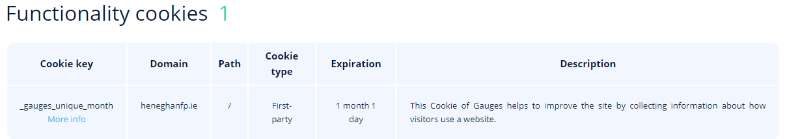
Performance Cookies
Preference cookies enable a website to remember information that changes the way the website behaves or looks, like your preferred language or the region that you are in.

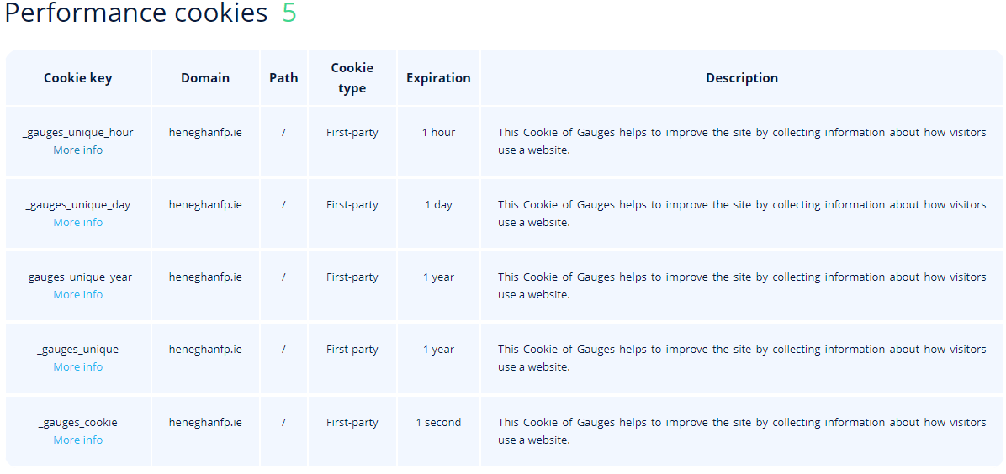

Glossary of technical terms used.
Firms should add as and when appropriate / updated as applicable

Personal data: means information that relates to you (Data Subject) which can identify you.

Personal data includes, but is not limited to, information such as your name, home address, work address, mobile phone, other phone, and fax numbers and/or other contact information, date of birth and Personal Public Service Number (‘PPSN’).
It can include the numbers of any policies you hold, your financial information, including details of any transactions completed for you. Personal data also includes any correspondence or other engagement you have with us or any of our service providers and any documentation connected to you or your policies that is held by us or on our behalf.

Personal data includes special categories of data which merit additional protection, such as data revealing your racial or ethnic origin, political opinions, religious or philosophical beliefs, or trade-union membership, and your genetic data, biometric data for the purpose of uniquely identifying you, or data concerning your health or sexual orientation. In addition, personal data includes data relating to criminal convictions and offences.

PII: Personal Identifiable Information which can identify a data subject (you).

Data Subjects: A Data Subject is a natural living person who can be identified either directly or indirectly, by reference to personal data.

Data Controller: A data controller is a person or company that’s responsible for deciding how personal data will be processed and for what reasons. For example, Heneghan Financial Planning Limited is a data controller for the personal data of our customers and staff.

Data Processor: A data processor is a person or company, usually a third party, that processes personal data on behalf of a data controller. They don’t decide how or why processing takes place, but instead carry out processing on the orders of a controller.

Cookies
Cookies are files with small amount of data, which may include an anonymous unique identifier. Cookies are sent to your browser from a website and stored on your computer’s hard drive. Small pieces of information, stored in simple text files, placed on your computer by a web site. Cookies can be read by the website on your subsequent visits so that you can access information in a faster and more efficient way. The information stored in a cookie may relate to your browsing habits on the web page, or a unique identification number so that the web site can "remember" you on your return visit. Generally speaking, cookies do not contain personal information from which you can be identified, unless you have separately furnished such information to the website.

IP address: The identifying details for your computer (or your internet company's computer), expressed in "internet protocol" code. Every computer connected to the web has a unique IP address, although the address may not be the same every time a connection is made.

Web browser: The piece of software you use to read web pages. Examples are Microsoft Internet Explorer, Netscape Navigator, Firefox and Opera.

